

**AQUA: A SOLAR-POWERED WATER QUALITY MONITORING AND RECORDING SYSTEM**

An Undergraduate Thesis

Presented to

The faculty of the

Electronics and Electrical Engineering Department

College of Engineering

In Partial Fulfillment

Of the Requirement for the Degree of

Bachelor of Science in Electronics Engineering

Daligdig, Arianne Dale O.

Fuentespina, Jane T.

Engr. Ria Marie P. Cordova

Adviser

January 2022

**Abstract**

Aquaculture is the world's fastest-growing food production method, with fish farms producing roughly half of all fish consumed by humans. It is specifically popular at the farm level in the Philippines since it increases rural employment, livelihood, and food security, thus growing the aquaculture industry's production. However, aqua farmers face several difficulties and concerns that impact their output. In this paper, the proposed system aimed to build an solar-powered water quality monitoring system in selected aquaculture sites in Mindanao that can transmit real-time data. Also, it simplified the water quality analysis which is critical in the decision-making and action-taking processes in water treatment. The prototype involved integrating sensors with the microcontroller, a wireless Zigbee module for broadcasting and receiving sensor values, and a ThingSpeak IoT platform for reviewing and visualizing uploaded water quality sensor results. The device showed a lot of potential in helping people ranging from locals to experts and aquaculture industries by increasing its yield production and reducing the fish kills.

**Keywords:** *Water Quality Monitoring System, Wireless Sensor Network, Water Quality Parameters, Aquaculture, Internet of Things*

**Table of Contents**

Title page

Abstract

Chapter

1: Introduction

Background of the Study

Statement of the Problem

Objectives of the Study

General objective/s

Specific Objective/s

Significance of the Study

Scope and Delimitations

Definition of Terms

2: Review of Related Literature

Related Literature

Related Studies

3: Methodology

System Design and Layout

Construction and Assembly

Technical Descriptions

Device and Accuracy

**Chapter 1**

**INTRODUCTION**

* 1. **Background of the Study**

Aquaculture is one of the most booming industries in many nations globally, as demand for fish and fish-prepared foods grows every day. In 2018, 179 million metric tons of fish were produced, of which 82 million were produced by aquaculture (FAO, 2020). In the Philippines during the first quarter of 2020, the volume of harvests from the aquaculture farms reached 525.24 thousand metric tons. It decreased by 0.2 percent from the 526.05 thousand metric tons produced during the same period in the previous year (PSA, 2021). In Mindanao specifically in Region 12, about 2,869.78 metric tons were produced from aquaculture fisheries in the 2nd quarter of 2020 and this is about 15.2 percent lower compared to the catch of 3,382.20 metric tons in the same quarter last year (PSA-SOCCSKSARGEN, 2020).

With this, the aquaculture industry is facing many problems; and it is due to the sudden climatic fluctuation that leads to changes in water quality parameters. According to BFAR-PHILMINAQ, the fish perform all its physiological activities in the water – breathing, excretion of waste, feeding, maintaining salt balance, and reproduction. Thus, water quality is the determining factor in the success or failure of an aquaculture operation. The continued degradation of water resources due to anthropogenic sources necessitates an improvement in sites for aquaculture using water quality as a basis. At present, aqua farmers rely on manual testing to determine water conditions; and it consumes time and produces inaccurate readings because water quality parameters may alter with time.

These problems being faced by the Philippine government stem from a lack of clear responsibilities, overlapping institutional boundaries, duplication of work, and a lack of coordination among involved institutions. All water quality monitoring programs in the country are constrained somehow by available laboratory facilities, instruments, transportation, and human resources; and may collect data primarily through direct sampling or limited water quality parameters. (Japitana et al., 2018) Specific information about water conditions, which is required to develop management strategies, is particularly scarce. (Deutsch et al., 2005)

With this, the researchers proposed a study that builds a portable and solar-powered on-site water quality monitoring and recording system that can deliver real-time data to the aqua farmers and government officials and record the current environmental status of the aquaculture sites for further analysis. This project will help prevent the water parameters from fluctuating to a dangerous level that affects the mortality rate of the organism. Also, this will help in addressing the decline of the production of fish in selected aquaculture sites in Mindanao, Philippines.

**1.2 Problem Statement**

When it comes to determining the lifetime of a network, energy issues such as energy scarcity and energy consumption in Wireless Sensor Networks (WSN) are the key factors that create concerns. Using wires to connect nodes to power lines nearby is not practical because the nodes usually distribute in remote places where the total expense in connecting all these nodes is unbearable. Another option is to solely utilize a battery. The benefits are evident, but batteries have a short lifespan and cannot last for lengthy periods. Replacing exhausted batteries regularly is time-consuming. Using a solar panel to power the sensor node and a battery to recharge when solar power is insufficient (such as at night), this solution will save time and effort while also making the system more deployable. Apart from that, traditional water quality monitoring systems rely on short-range, high-power wireless technologies, which are inconvenient for wireless sensor nodes in a Wireless Sensor Network (WSN). As a result of these concerns, this proposed project provides a device designed to address energy difficulties in WSNs, as well as a low-cost, low-power, and scalable water quality monitoring strategy based on the Zigbee protocol, which is significantly more efficient than many current systems. Furthermore, slow fish growth and fish kills in fisheries are problems that every fish farmer faces in the aquaculture industry. Water quality is a critical factor that must be monitored from time to time when culturing any aquatic organism; however, most fish farmers do not consider it because traditional water testing and water sensors are done manually, expensive and difficult to use. As we integrate the Internet of Things, this novel system that we proposed will certainly speed-up the time needed to test the water parameters.

**1.3 Objectives of the Study**

**1.3.1 General Objective**

The main objective of this research is to develop a real-time water quality progress report for water treatment ensuring a safe natatory environment for aquaculture using Raspberry Pi.

**1.3.2 Specific Objectives**

This research project aims to achieve the following:

1. Design and construct the AQua device using Raspberry Pi.
2. Monitor and measure the water pH, temperature, and turbidity using available sensors at remote places.
3. Assess the accuracy of the results when applied to a wide range of water conditions.
4. Provide local power supply to sensor nodes using solar energy and collect the data from various sensor nodes and send it to base stations by a wireless channel which are connected using Wireless Sensor Network technology like Zigbee.
5. Simulate and analyze the quality parameters for quality control using ThingSpeak and publish the corresponding record over the web for public information and further assessment of water resources.

**1.4 Significance of the Study**

This research study, AQua: a solar-powered water quality monitoring and recording system is proposed in order to be significant to the following:

**To Aquaculturists**. The device will help the aquaculturist by delivering real-time data to the aqua farmers and government officials and record the current environmental status of the aquaculture sites for further analysis. This project will help prevent the water parameters from fluctuating to a dangerous level that affects the mortality rate of the organism. Also, this will help in addressing the decline of the production of fish in selected aquaculture sites in Mindanao.

**To the Future Researchers**. They can use this study as their reference to additionally extend the usage of Zigbee module, Raspberry Pi and ThingSpeak IoT in water quality monitoring and in other fields as well.

**To the University**. This study will be of use to the Mindanao State University particularly engineering students who suppose they might be intrigued and inspired to invoke more splendid thoughts, characterizations of innovative progressions that would be of future use to the College of Engineering with accomplishing its objective and to further develop the said water quality monitoring system.

**To the Researchers**. This study will be an opportunity for them to apply the knowledge and illustrations gained from subjects related to this study and help them further practice their decisive reasoning. Moreover, this will also give the researchers to be more exposed and gain experience as they need to be focused and hands-on in this study.

**1.5 Scopes and Delimitations**

This project's main objective is to create an onsite and energy-efficient IoT-based water quality monitoring and recording system using a Raspberry Pi. It focuses mainly on the sensor's and device's accuracy in contrast to typical laboratory equipment and the speed and range of data transmission via Zigbee module interface. Only the pH, temperature, and turbidity of the water will be measured by the device. The study's threshold values are solely based on Department of Environment and Natural Resources' (DENR) standard levels. This device is solely for determining the water quality of aquaculture industries in selected sites in Mindanao.

**1.6 Definition of Terms**

**Definition of Terms**

***AQua***- the name of the device that will monitor and record the water quality of Aquaculture sites in region 12

***Aquaculture***- is the practice of raising aquatic animals and plants in controlled and managed environments.

***Fishkill***- massive destruction of fish stocks in a specific area due to unacceptable or toxic water quality conditions in a specific aquatic environment.

***Raspberry Pi-*** is a small form-factor single-board computer that can process simultaneously

***Solar energy***- the power source of the AQua device

***ThingSpeak-*** an IoT platform for reviewing and visualizing water quality sensor results.

***Water Parameters***- are the ones monitored for water quality and it includes temperature, pH, and turbidity.

***Water Pollution***- contamination of the body of water that degrades water quality and makes it toxic to humans and the environment.

***Water Quality***- describes the condition of the water, including chemical, physical, and biological characteristics.

***Wireless Sensor Network (WSN)***- used for water quality monitoring it is collected by sensors and then transmitted to a server.

***Zigbee module***- for broadcasting and receiving sensor values.

**Chapter 2**

**1REVIEW OF RELATED LITERATURE**

This chapter contains the related literature and studies based on the proponents' extensive

study. This chapter also provides a brief overview of existing systems and technologies similar to

the project at hand.

**2.1 Related Literature**

**2.1.1 Aquaculture**

Aquaculture is the world's fastest-growing food-production sector. It is the practice of raising, breeding, and harvesting aquatic animals and plants in controlled aquatic environments such as oceans, lakes, rivers, ponds, and streams. It also has inherent features that make it one of the most cost-effective and low-impact methods of producing high-quality protein for humans. Compared to traditional animal agricultural methods, these advantages include a significantly higher food conversion efficiency. All systems, on the other hand, must provide the same ecological functions, such as maintaining an acceptable culture temperature, ensuring enough oxygen levels, and removing dangerous waste products (Tidwell and Bright, 2018; Schramm and Grist, 2021)

**2.1.2 Fish Kills**

According to the BFAR, fishkill is defined as the "massive destruction of fish stocks in a specific area due to unacceptable or toxic water quality conditions in a specific aquatic environment." Some cases are caused by human activities, but natural causes account for roughly half of all cases worldwide. Some of the most common reasons include algal blooms and the related water quality issues, such as low oxygen or toxin development (Vera-ruiz, 2021).

**2.1.3 Water Parameters**

Depending on the intended water parameters of interest, chemical, physical, and biological aspects of water can all be analyzed or monitored. Temperature, dissolved oxygen, pH, conductivity, ORP, and turbidity are just a few of the water quality metrics that are commonly measured or monitored.

**2.1.3.1** **pH**

Extremely low or extremely high pH water is fatal. Only a few organisms can survive in water with a pH of below three or beyond eleven, and most fish will die if the pH is below four or above ten. Water that is somewhat acidic (low pH) can diminish the number of hatched fish eggs, irritate fish and aquatic insect gills, and damage membranes (Omer, 2019).

**2.1.3.2 Temperature**

The temperature of water is one of its most basic properties, and many other factors rely on it for accuracy. We can use temperature data to monitor thermal loading or discharge, as well as measure changes in the thermocline, which has an impact on the health of aquatic animals and critters. Many aquatic organisms are harmed by high temperatures because less oxygen dissolves in the water, clouds prohibit plants from creating enough oxygen through photosynthesis, and calm breezes inhibit turbulence and mixing of atmospheric oxygen with surface water. Warmer water has a lower oxygen solubility, which reduces oxygen delivery. Furthermore, because larger fish demand more oxygen than smaller fish, they usually perish first (Sallenave, 2013).

**2.1.3.3** **Turbidity**

Suspended particles can block or harm fish gills, reducing disease resistance, growth rates, egg and larval maturation, and the efficacy of fish capture methods. Higher turbidity boosts water temperatures, which limits the amount of accessible food, because suspended particles absorb more solar heat. As a result, the concentration of dissolved oxygen (DO) can be lowered since warm water carries less dissolved oxygen than cold water (Omer, 2019).

**2.1.4 Wireless Sensor Network Technology**

Recent technologies in wireless communications and electronics have brought the vision of Wireless Sensor Network (WSN) into reality which have increased the growth of low cost, low power and multi-functional sensors that are small in size and can communicate in short range. Each node consists of microcontrollers, memory and transceiver. The microcontrollers are used to execute tasks, data processing and assist the functionality of other components in the sensor node. For the memory, it is mainly used for data storage while the transceiver acts from the combination of transmitter and receiver functions. Natural phenomena data such as temperature, light, sound and pressure are collected by sensors and then transmitted to a server. These battery powered nodes are used to monitor and control the physical environment from remote locations. In the past few years, the applications of Wireless Sensor Network have been widely used and applied in medical, military, industrial, agricultural and environmental monitoring (Mohd, 2011).

In order to collect data about the surrounding environment, wireless sensor networks (WSNs) are made up of interconnected sensor nodes that interact wirelessly. Nodes are often low-power and distributed in a decentralized, ad hoc manner. Although WSNs have acquired a lot of traction, resource restrictions in memory, compute, battery life, and bandwidth have placed some major limitations when it comes to establishing security. Privacy, control, and availability are all targets of a variety of assaults. (Patil & Chen, 2017)

**2.2 Related Studies**

There are few papers published that focus on how changes in water quality parameters will affect aquatic life and how the Internet of Things (IoT) can be used to solve these types of issues and problems, as IoT has recently reached the ground level with its application to agriculturists. Also, a great deal of research is being done with various studies related to water quality monitoring systems.

In the study of Alave et al. (2020), they focused on designing a water quality monitoring system that can indicate whether the water is safe to drink. Their monitoring system includes a PH sensor, a turbidity sensor, and total dissolved solid sensor, as well as an Arduino Uno as the main board. The core controller processed the values measured by the sensors. Furthermore, their device utilized the Global System for Mobile Communication (GSM) module which sends information on all the parameters analyzed at a specific time interval and warning if any parameters' values exceed the permissible levels. Despite the fact that their research achieved substantial findings, they recommended using an environmentally friendly power source that can offer the requisite voltage for the prototype to function properly without causing any power shortage.

Furthermore, a study conducted by Simitha and Subodh (2019), entitled “IoT and WSN Based Water Quality Monitoring System”, uses several sensors such as pH, temperature, turbidity, and dissolved oxygen. Their proposed system for water quality monitoring used the LoRa module based on LoRaWAN protocol which is Low-Power Wide Area Network (LPWAN) technology. As they have concluded, their system performed well as per the design. But when we researched further, we found out that LoRa is not suited for real time applications that require lower latency (Devalal and Karthikeyan, 2018) which is a great factor in real-time systems.

In light of this, we assessed the paper of Olatinwo and Joubert (2018) entitled “A Review on Energy Efficient Solutions in Wireless Sensor System for Monitoring the Quality of Water” which presented several techniques for solving energy problems in WSN. The review identified several challenges, strengths, and weaknesses associated with several energy-efficient techniques based on optimization, EH, and wireless energy transfer techniques. Furthermore, several suggestions for future directions to improve on the identified issues have been made. The goal of their research is to advance the field of water quality monitoring using wireless sensor networks in the context of long-term network operations. After thorough consideration and evaluation, we decided to go with a solar energy harvesting system to supply the power of the device that we proposed because it has several advantages, including no carbon emissions, low power consumption, greater flexibility in deployment at a remote site, and so on (Satish and Amruta, 2013)

**Chapter 3**

**METHODOLOGY**

The goal of the research is to develop an onsite and solar-powered water quality monitoring and recording system. To accomplish this, the development was divided into 4 parts: (1) The designing of the device, (2) the assembly of the main circuitry, (3) the construction of the device chassis, and (4) the accuracy tests.

**3.1 System Design and Layout**

The water parameter sensing node integrates sensors in real-time water quality monitoring and recording systems. These sensor values are displayed through the LCD monitor. Moreover, the data collected by the sensors is sent to the base stations by a wireless sensor network technology called Zigbee then transfers it to the ThingSpeak server through the ESP32 Wi-Fi gateway module. The quality parameters acquired are then stored, simulated and analyzed for quality control using ThingSpeak and publish corresponding records over the web for public information and further assessment of water parameters. An alarm notification will be sent through email using MATLAB or IFTTT programming if any of the parameters' values exceed the permissible levels. The detailed flowchart is shown in Figure 3.1.

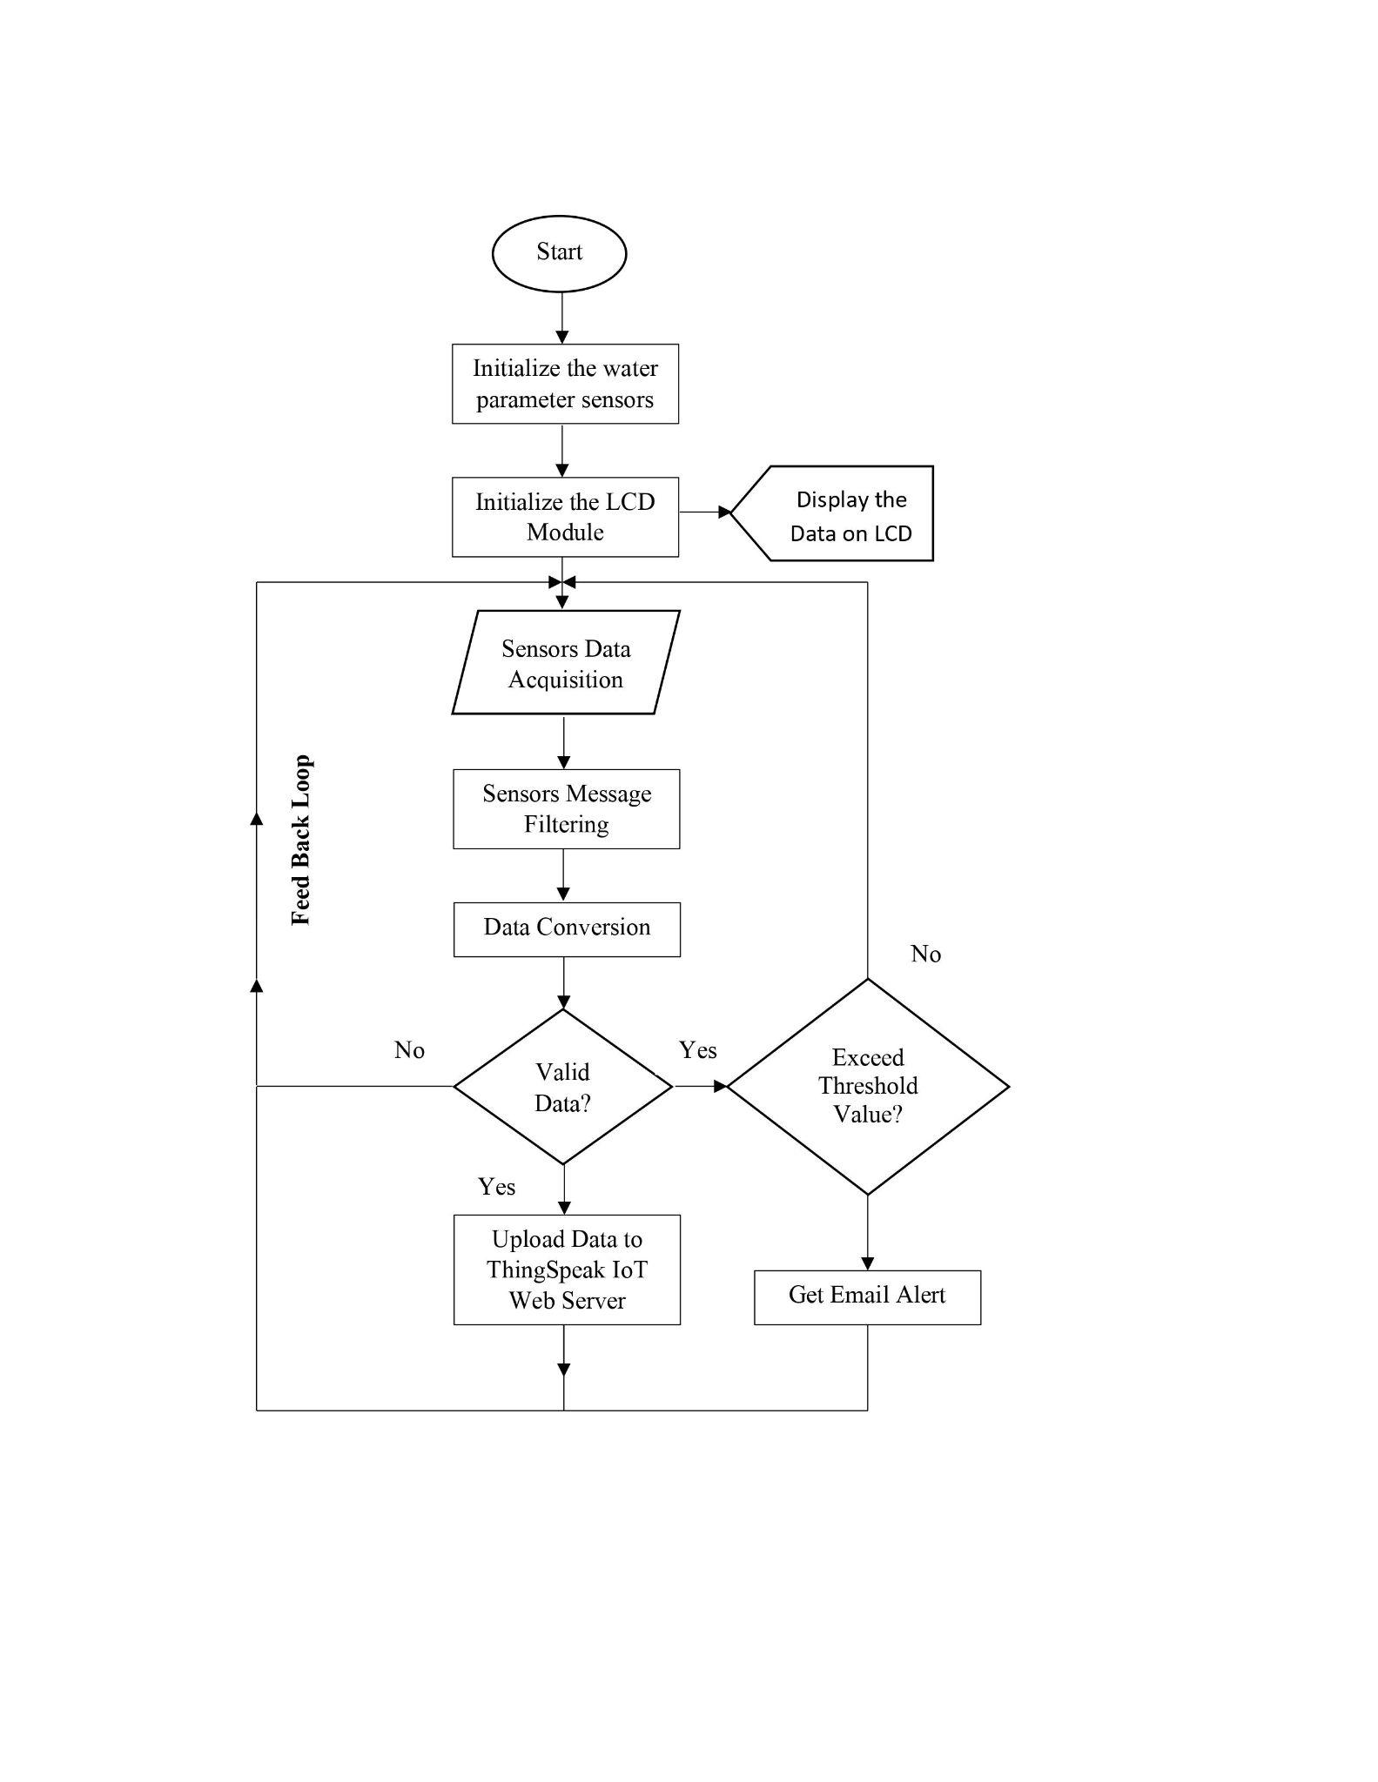

**Figure 3.1 Research Methodology Flowchart**

The whole block diagram of the study is shown in Figure 3.2. The solar cell power supply gives power to the sensors, Raspberry Pi, ATMega328 microcontroller, ESP32 gateway module, and Zigbee module. The sensors are the pH sensor, temperature, and turbidity sensor. The Zigbee module will be used to connect the nodes and base station. The data obtained by various sensors on the node side will be sent to the base station where the data can be displayed in a visual manner and analyzed using ThingSpeak.

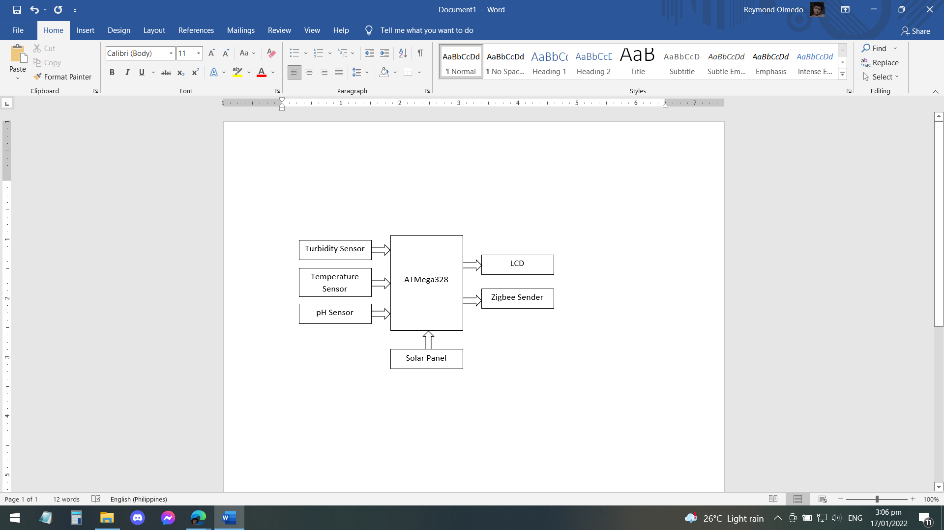

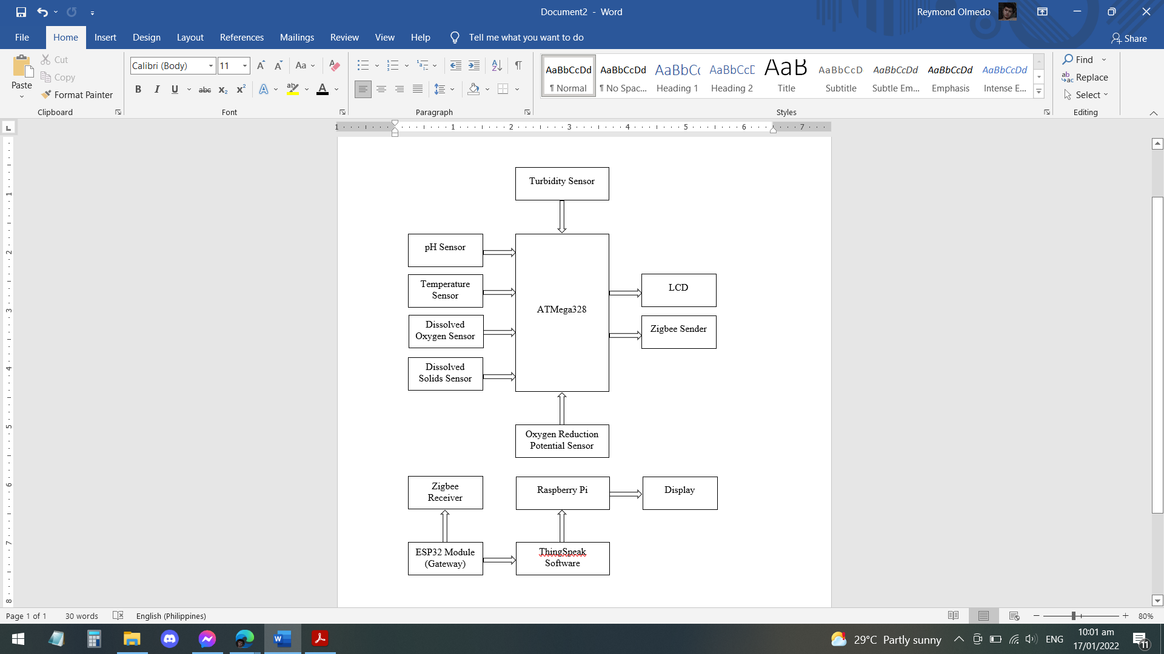

**Figure 3.2 System Block Design**

**3.2 Construction and Assembly**

The AQua device contains three sensors (namely the pH sensor, the temperature sensor, and the turbidity sensor) which are connected to one main microcontroller (Raspberry Pi) together with the Zigbee module. The case of the device is box-shaped and will be made out of acrylic due to its low cost material, water resistance ability, and well-known availability. It houses all the main parts of the device. The two tubes on each side function as a floating device. The pipes on each side are outlets for the sensor and are covered by mesh to avoid fish eating the sensors or bumping into them. Figure 3.3 shows the inspiration of the AQua device from Tolentino et al (2021) in relation to its illustration and its parts.

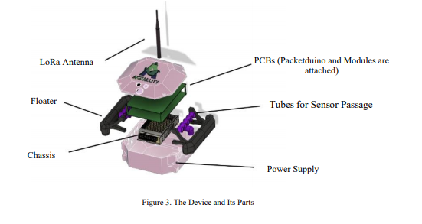

**Figure 3.3 The Proposed Device and its Parts**

**3.3. Technical Descriptions**

**3.3.1 Raspberry Pi**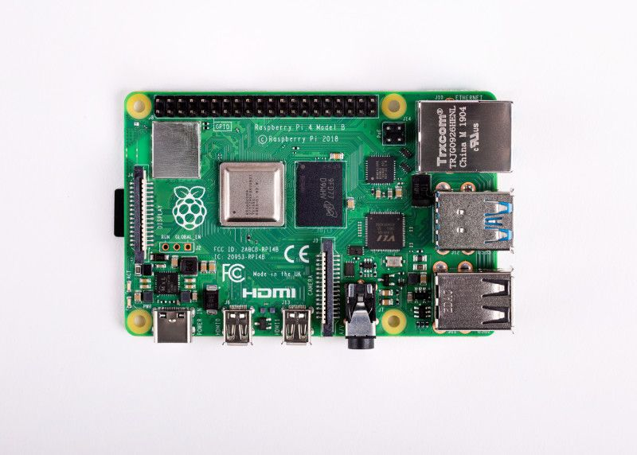

**Figure 3.4 Raspberry Pi**

The Raspberry Pi is a low-cost, credit-card-sized computer that connects to a computer monitor or TV and operates with a standard keyboard and mouse. It is a capable little device that allows people of all ages to experiment with computing and learn to program in languages such as Scratch and Python.

**3.3.2 Solar Power Module**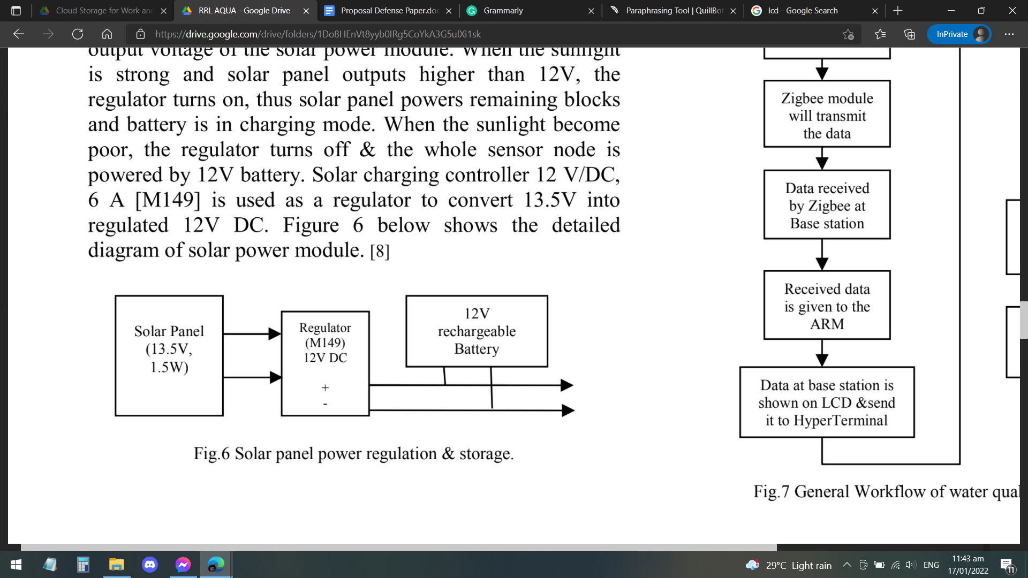

**Figure 3.5 Solar Panel Power Regulation and Storage**

The solar panel employed has an output voltage of 13.5V and a power of 1.5W. Since the sunlight changes throughout the day and night, a battery with a 12V output is utilized to keep and sustain the solar power module's output voltage. The regulator switches on when the sunlight is strong and the solar panel outputs more than 12V, allowing the solar panel to power the remaining blocks and the battery to charge. The regulator switches off when the sunlight is poor, and the entire sensor node is powered by a 12V battery. To convert 13.5V into regulated 12V DC, the solar charging controller 12 V/DC, 6 A [M149] is utilized as a regulator. The detailed diagram of a solar power module is shown in Figure 3.5 above.

**3.3.3 ATMega328 Microcontroller**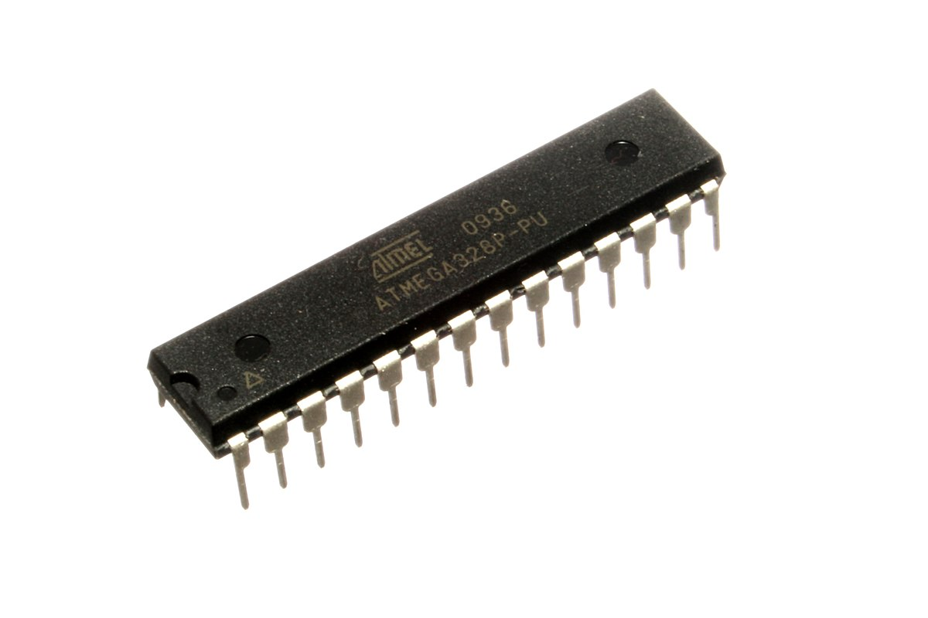

**Figure 3.6 ATMega328**

The ATmega328 is a microcontroller from the megaAVR family. It is an 8-bit RISC processor core with a Harvard architecture that has been modified and is a 28-pin IC with 32KB of code space. The ATmega328 in Figure 3.6 has 32KB flash memory, 1KB EEPROM, 2KB SRAM, 23 I/O lines, USART, SPI, 10 bit ADC, programmable watchdog timer, and 5 sleep modes for power management. The device's operating voltage ranges from 1.8 to 5.5 volts. It can store data even if its power supply is turned off. With the ATmega328, an external crystal oscillator of 16MHz is used. This microcontroller is low-cost and power-dissipating. It also has a programming lock and a real-time clock with a different oscillator and is ideal for low-power embedded system projects.

**3.3.4 ESP32 Wi-Fi Module**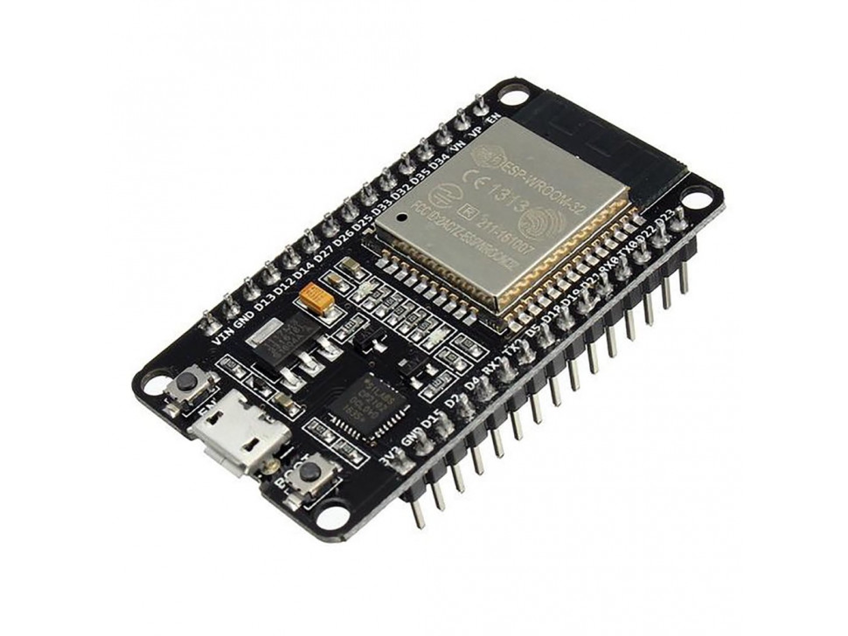

**Figure 3.7 ESP32 Wi-Fi Module**

The ESP32 is a low-power IoT sensor chip. It is a 32-bit, 2.4-GHz Wi-Fi designed with low-power technology. The ESP32 microprocessor includes 520KiB of SRAM and 4MiB of flash memory. It is a 48-pin integrated circuit that supports SPI and I2C interfaces.

**3.3.5 DS18B20 Temperature Sensor**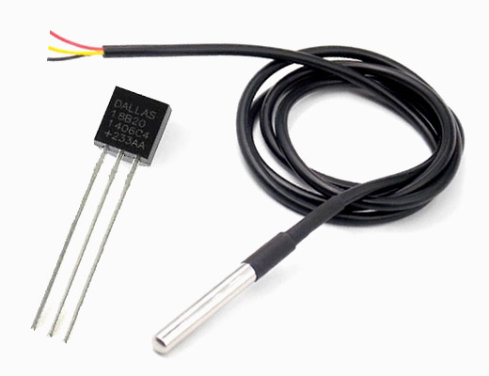

**Figure 3.8 DS18B20 Temperature Sensor**

The DS18B20 is a waterproof temperature sensor probe with a 12bit ADC built in. The probe type sensor is ideal for sensing the temperature of water in our proposed AQua device because it is convenient and used when measuring something far away or in wet conditions. The sensor's operating voltage ranges from 3V to 5V. The DS18B20 also has programmable alarm options, 12 bits of precision, and a temperature range of -55 to 125°C.

**3.3.6 pH Sensor Module E201-C-9**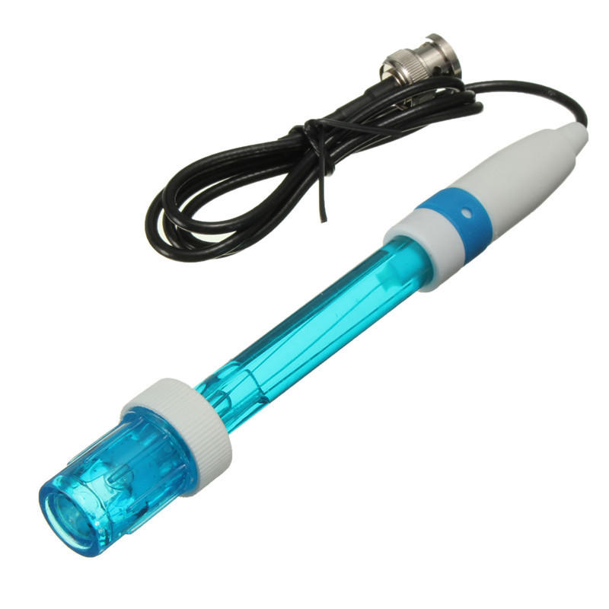

**Figure 3.9 pH Sensor Module E201-C-9**

The pH sensor module depicted in Figure 3.9 is made up of a pH sensor known as a pH probe with a BNC connector and a signal conditioning board that produces an output proportional to the pH value and can be directly interfaced to the microcontroller. E201-C-9 is the model number used here. It is a type of probe. Acidity meter electrode with a plastic shell that can be recharged. It is refillable, has a round surface, and is suitable for rugged use in the field, schools, and laboratories where routine pH calculations are required. It is Arduino-compatible. This meter has a pH measurement range of 0 to 14. The operating temperature range is 5 to 60 degrees Celsius.

**3.3.7 TS-300B Turbidity Sensor**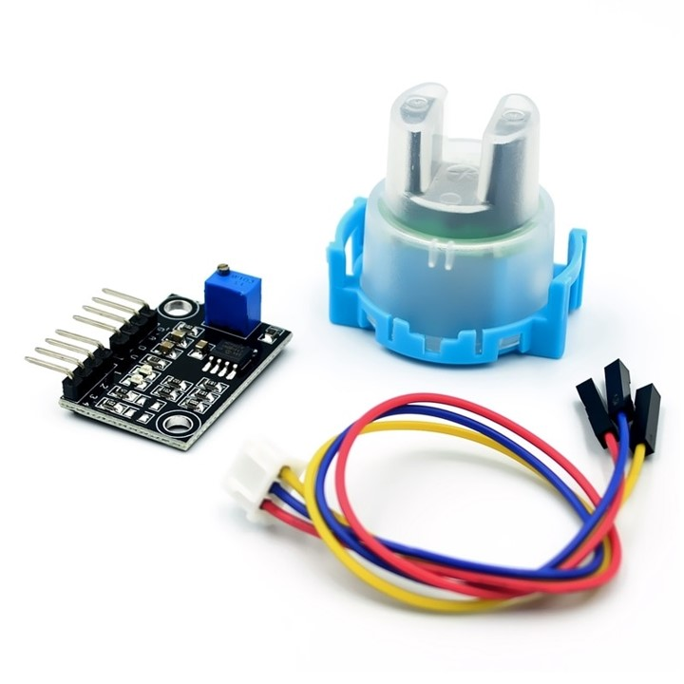

**Figure 3.10 TS-300B Turbidity Sensor**

The TS-300B is a high-quality turbidity sensor with an analog and digital interface for the Arduino. This is the Arduino Turbidity Sensor DIY Projects at a Low Cost. The degree of turbidity caused by suspended matter in water, such as sediment, clay, organic matter, plankton, and microorganisms, is referred to as water turbidity. The module is inexpensive, easy to use, and has a high measurement accuracy. It can be used to measure the degree of water pollution caused by washing machines, dishwashers, and other appliances; it can also be used for industrial site control, environmental sewage collection, and other situations requiring turbidity detection and control.

**3.3.8 Zigbee Module**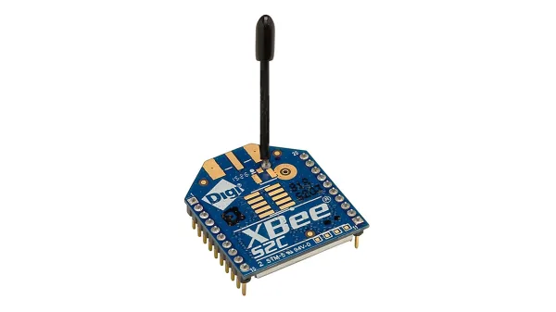

**Figure 3.11 Zigbee Module**

ZigBee is a standard protocol that combines the physical Radio Frequency (RF) layer with the IEEE 802.15.4 physical radio specification and operates in unlicensed bands such as 2.4 GHz, 900 MHz, and 868 MHz [4,8]. Except for the GSM modem network, this project utilised the 2.4 GHz ISM frequency band for all nodes. ZigBee's smart, cost-effective, and energy-efficient mesh network is defined by the core ZigBee specification. It's a self-configuring, self-healing system of redundant, low-cost, very low-power nodes that allows ZigBee to have its distinctive flexibility, mobility, and ease of use. WSN futures will also have an energy-saving coverage due to its tiny size and battery life dependence, which is limited to be powered. It can run for years on affordable batteries, making it ideal for a variety of monitoring and control applications. As a result, the 'active' and 'hibernation' nodes will aid in power conservation (Nasirudin et al, 2011).

**3.3.9 ThingSpeak Server**

**Figure 3.12 ThingSpeak Software Logo**

ThingSpeak is an IoT data collection platform used for analyzing, examining, and visualizing water quality sensor values that have been uploaded to the cloud, such as pH, turbidity, voltage, temperature, moisture, distance, and so on. The data collector collects data from edge node devices and also allows for data modification for historical data analysis in a software environment. The user must first log in using his or her server's credentials. The core component of ThingSpeak activity is the channel, which has data fields and a status field. Data is updated, analyzed, and interpreted with MATLAB code when a ThingSpeak channel is created, and the data is reacted to with tweets and other notifications ( Das and Jain, 2017; Simitha and Raj, 2019).

**3.4 Device Accuracy Tests**

The collected data was compared against the traditional way of data gathering for each parameter to ensure that the results were credible. To be considered accurate, each datum obtained by the gadget must be within 5% of the traditional method's test findings (Alave et al, 2020).

**BIBLIOGRAPHY**

Alave, E. N. L., Lim, H. A. G., Ronquillo, J. L., & Tugade, M. M. (2020). PORTABLE ARDUINO-BASED INTEGRATED WATER QUALITY ANALYZER WITH REAL-TIME DATA TRANSMITTER.

Boyd, C., 2013. Reference Module in Earth Systems and Environmental Sciences. Elsevier.

Das, B., & Jain, P. C. (2017, July). Real-time water quality monitoring system using Internet of Things. In 2017 International conference on computer, communications and electronics (Comptelix) (pp. 78-82). IEEE.

Deutsch, W. G., Busby, A. L., Orprecio, J. L., Bago-Labis, J. P., & Cequina, E. Y. (2005). Community-based hydrological and water quality assessments in Mindanao, Philippines. Forests Water & People in the Humid Tropics, 134-149.

Devalal, S., & Karthikeyan, A. (2018, March). LoRa technology-an overview. In 2018 Second International Conference on Electronics, Communication and Aerospace Technology (ICECA) (pp. 284-290). IEEE.

FAO. (2020). STATE OF WORLD FISHERIES AND AQUACULTURE 2020 : sustainability in action. Food & Agriculture Org.

FAO Fisheries & Aquaculture. (n.d.). Www.fao.org. Retrieved January 7, 2022, from https://www.fao.org/fishery/en/countrysector/naso_philippines

Fisheries Situation Report, January to arch 2021 | Philippine Statistics Authority. (n.d.). Psa.gov.ph. Retrieved December 15, 2021, from https://psa.gov.ph/content/fisheries-situation-report-july-september-2021-0

Satish, T., & Amruta, K. (2013). Solar powered water quality monitoring system using wireless sensor network. In IEEE Conference on Automation, Computing, Communication, Control and Compressed sensing, IEEE (pp. 281-285).

Mohd. Ezwan Jalil. (2011). Positioning and Location Tracking Using Wireless Sensor Network (Doctoral dissertation, Universiti Teknologi Malaysia).

Nasirudin, M. A., Za'bah, U. N., & Sidek, O. (2011, September). Fresh water real-time monitoring system based on wireless sensor network and GSM. In 2011 IEEE Conference on Open Systems (pp. 354-357). IEEE.

Olatinwo, S. O., & Joubert, T. H. (2018). Energy efficient solutions in wireless sensor systems for water quality monitoring: A review. IEEE Sensors Journal, 19(5), 1596-1625.

Omer, N. H. (2019). Water quality parameters. Water quality-science, assessments and policy, 18.

Patil, H., & Chen, T. (2017). Wireless Sensor Network Security. Computer And Information Security Handbook, 317-337. doi: 10.1016/b978-0-12-803843-7.00018-1

Sallenave, R. (2013). Understanding and preventing fish kills in your pond. NM State University, Cooperative Extension Service.

Schramm, D., & Grist, C. (2021). BUILDING SITE SELECTION TO CONSERVE ENERGY BY OPTIMIZING TOPOCLIMATIC BENEFITS: A Possible Use for Computer-Based Data Manipulation and Mapping Systems. In Energy Resources and Conservation Related to Built Environment (pp. 308-318). Pergamon.

Simitha, K. M., & Raj, S. (2019, June). IoT and WSN based water quality monitoring system. In 2019 3rd International conference on Electronics, Communication and Aerospace Technology (ICECA) (pp. 205-210). IEEE.

SOCCSKSARGEN REGION’s 2nd QUARTER 2020 FISHERIES PRODUCTION UP BY 23.0 PERCENT | Philippine Statistics Authority SOCCSKSARGEN Region. (2020). Psa.gov.ph.http://rsso12.psa.gov.ph/article/soccsksargen-region%E2%80%99s-2nd-quarter-2020-fisheries-production-230-percent

Tidwell, J. H., & Bright, L. A. (2019, January 1). Freshwater Aquaculture (B. Fath, Ed.). ScienceDirect; Elsevier. https://www.sciencedirect.com/science/article/pii/B9780124095489106189

Tolentino, L. K., Chua, E. J., Añover, J. R., Cabrera, C., Hizon, C. A., Mallari, J. G., ... & Fernandez, E. (2021). IoT-Based Automated Water Monitoring and Correcting Modular Device via LoRaWAN for Aquaculture. International Journal of Computing and Digital Systems, 10, 533-544.